Shakespear’s Macbeth
Powers of the witches as depicted in I,1 & I,3
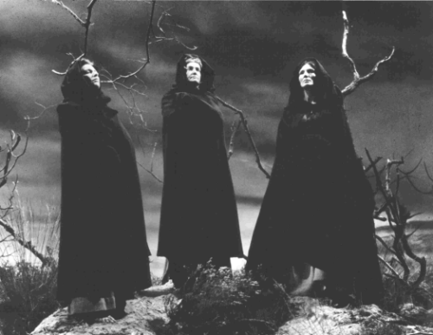
Task 1
Right or wrong? Find evidence in the text!
Witches…
… may take the shape of an animal without tails.
Proof in the text: ____________________________________________________________________
… can fly.
Proof in the text: ____________________________________________________________________
… command wind and sea.
Proof in the text: ____________________________________________________________________
… can put a spell on people.
Proof in the text: ____________________________________________________________________
… can sail the sea in sieves.
Proof in the text: ____________________________________________________________________
… can raise storms.
Proof in the text: ____________________________________________________________________
… can kill farm animals by inflecting them.
Proof in the text: ____________________________________________________________________
… can kill kings.
Proof in the text: ____________________________________________________________________
… harass soldiers.
Proof in the text: ____________________________________________________________________
… vanish and appear as they please.
Proof in the text: ____________________________________________________________________
… need not eat or drink.
Proof in the text: ____________________________________________________________________
… can deflect ships from their course.
Proof in the text: ____________________________________________________________________
… are able to make prophecies.
Proof in the text: ____________________________________________________________________
Task 2
Characterize the witches by using moral values!
________________________________________________________________________________________________________________________________________________________________________________________________________________________________________________________________________________________________________________________________________________________________________________________________________________________________________________________________________________________________________________________________________________________________________________________________________________________________________________________________________________
Task 3
How is their character reflected by their outward appearance?
________________________________________________________________________________________________________________________________________________________________________________________________________________________________________________________________________________________________________________________________________________________________________________________________________________________________________________________________________________________________________________________________________________________________________________________________________________________________________________________________________________
Task 4
What is their function in I, 1 and in I, 3?
________________________________________________________________________________________________________________________________________________________________________________________________________________________________________________________________________________________________________________________________________________________________________________________________________________________________________________________________________________________________________________________________________________________________________________________________________________________________________________________________________________

Have fun!

